Create landing page of some T-shirt store with shop section.

When user came to this page he should see list of available product with filter section:

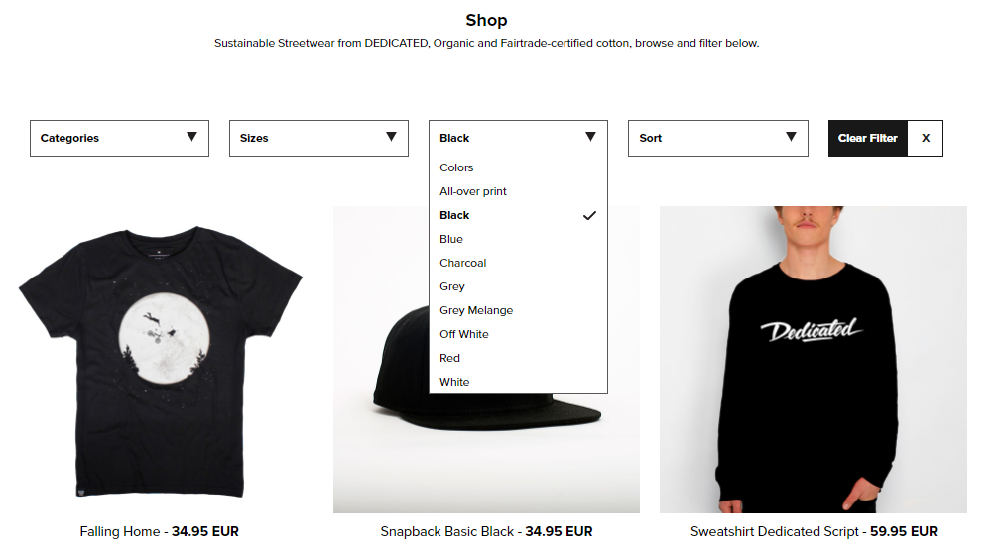

User should be able to filter products by:

* Category
* Size
* Color

User should be able to sort product by:

* Lowest price first
* Highest price first

Clicking on product will send user to next flow page:

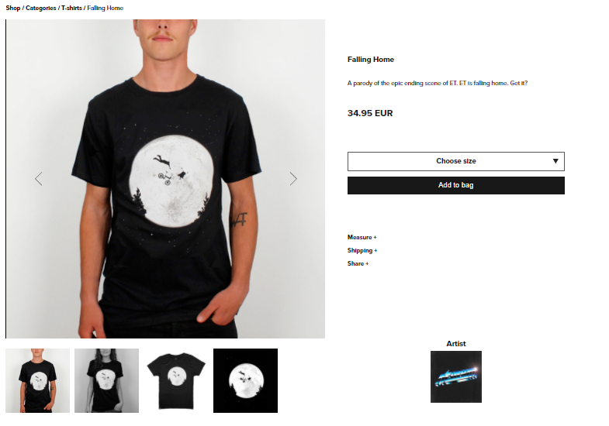

On this page user will see slider that will be switching automatically every 2s

User can set size and add product to bag.

When product was added to cart, button will change to “Proceed to checkout”

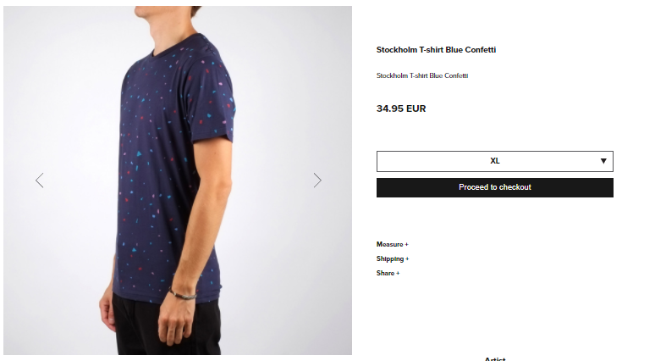

Count of items in Bag/Cart will indicated with icon and count number inside that icon



Clicking on that item or “Proceed to checkout” button will move us to Checkout Page

User should be able remove items, change count of items, and apply Discount by entering voucher code.

* voucher code is “disck10” provide 10% Discount
* voucher code is “disck5eur” provide 5EUR Discount

Required Fields:

* FirstName
* LastName
* Email

If not valid should provide to User some error

After purchase should show new page with list with of purchased items.

Cart should be reset.

